**Programme:**

**MSC IN BUSINESS ANALYTICS**

**Module:**

**Project Management for Business Analytics - B9BA105**

**Assignment Title:**

**CA 1 – Agile Project Management**

**Submitted to: Submitted By:**

## Mrs. Vinette McNamara Rohit Verma 10635420

## Robin Varma 10631497

## Abhinav Singh Voria 10634732

## Adeel Hassan 10286506

**Table of Contents**

List of Figures 4

List of Tables 5

Agile Project Charter for E-commerce Website Development 6

Aim of the website 7

Key Features of ShopeEase 7

Techniques Employed to Create the Website: 8

Front-end Development: 8

Back-end Development: 8

Designing a user interface (UI) 8

Front-end Developer: 8

Back-end Developer: 9

Designer of UI/UX: 9

Features of ShopeEase: 9

Goal: 10

Objectives: 10

Scope of the project 10

Milestones: 11

Work Breakdown Structure (WBS): 12

Schedule Plan 14

Project budget and Earned Value Management analysis 15

Project Budget 15

Earned Value Management analysis 16

Agile Roles in E-commerce Website Development 17

Product Owner 18

Scrum Master 19

Development Team 19

Interactions between Roles 19

Agile Techniques for Project Planning and Monitoring 20

Scrum for ShopeEase Website Development: 20

Kanban for ShopeEase Website Development: 21

Solution Development Team Management in ShopEase Website Development 23

Consistent Meetings: 24

Tools for Collaboration: 25

Constant Improvement: 26

Teamwork and Issue Resolution: 26

Communication with Business Stakeholders in E-commerce Website Development 23

Communication Plan 23

Regular Status Reports 24

Stakeholder Meetings 26

Incorporating and Gathering Feedback 30

Agile Techniques and On-Time Project Delivery in ShopEase Website Development 32

Agile Techniques for Requirement Prioritization: 32

Iterative and Incremental Nature of Agile Development: 36

Risk Management in ShopeEase Website Development 37

Identifying Risks 37

Risk Register 38

Qualitative and Quantitative Risk Assessment 39

Risk Thresholds and Tolerances 40

Stakeholder analysis 41

Risk Register 42

References 44

# List of Figures

Figure 1: Gantt chart 14

Figure 2: Critical path 14

Figure 3: Earned Values analysis 16

Figure 4: Agile Methodology 18

Figure 5: Scrum process 21

Figure 6: Kanban process 22

***Figure 7: Consistent Meetings*** 24

Figure 8: Tools for Collaboration 25

***Figure 9: Teamwork and Issue Resolution*** 26

**Figure 10: Communication Plan** 28

**Figure 11: Regular Status Reports** 29

**Figure 12: Stakeholder Meetings** 30

**Figure 13: Incorporating and Gathering Feedback** 31

Figure 14: MoSCoW Prioritization 33

Figure 15: User narrative Mapping 34

Figure 16: Value-Based prioritising 35

Figure 17: Kano Model 35

Figure 18: Iterative and Incremental Nature of Agile Development 36

**Figure 19: Identifying Risks** 38

**Figure 20: Risk Register** 39

**Figure 21: Risk Register** 40

**Figure 22: Risk Thresholds and Tolerances** 41

# 

# List of Tables

Table 1: Scope statement 10

Table 2: Budget of the project 15

Table 3: Earned value analysis 16

Table 4: Stakeholder analysis 41

***Table 5: Risk Register*** 42

# Introduction

Planning, organizing, carrying out, and controlling the many tasks and resources involved in a project in order to achieve certain goals and objectives within a set scope, schedule, and budget is the discipline of project management. In order to successfully achieve the intended results, it is the process of leading and organizing all project-related tasks and team members.

*Project management's essential components include:*

Defining the project's goals, deliverables, and scope is part of planning. creating a thorough project plan including tasks, deadlines, resource allocators, and risk evaluations.

**Organising**: Putting together a project team with the appropriate expertise and defining each team member's tasks. establishing routes of communication and governance frameworks.

**Execution**: Carrying out the specified tasks and activities as well as the project plan. Following up on developments, controlling changes, and resolving any problems that may emerge during a project.

**Controlling**: Monitoring and evaluating project progress in relation to budget, time, and quality targets. implementing corrective measures to keep the project on course and within its established parameters.

**Closing**: Complete the project by making sure all deliverables have been met with the necessary criteria. creating documentation and project reviews for future use.

Project management is crucial for making sure that tasks are carried out effectively, promptly, and affordably while accomplishing the desired goals. It can be used in a variety of industries and sectors, allowing firms to meet their strategic objectives and provide value to their stakeholders. Leadership, communication, risk management, and flexibility are necessary for effective project management in order to handle the dynamic nature of projects and adapt to changing circumstances.

# Agile Project Charter for E-commerce Website Development

A fashion e-commerce site called ShopeEase has a huge selection of clothes and accessories for Men's, Women's, and Children's wear. The website tries to solve the problems users frequently run into when utilizing online buying platforms. ShopeEase seeks to improve all aspects of the user experience by offering a visually appealing and intuitive interface that makes it simple for customers to browse and find the products they want. Every visitor will have a seamless and delightful buying experience thanks to the website's simplicity and intuitive design, which will remove navigational challenges.

## Aim of the website

ShopeEase is an e-commerce website which will be focused on shopping for clothing for men, women, and children a seamless and joyful experience for its clients. The website will concentrate on fixing user experience and navigational problems encountered by visitors as they browse the site. ShopeEase promises to make it easier for customers to identify and purchase their favorite fashion products by providing a visually appealing and user-friendly interface.

## Key Features of ShopeEase

* User-Friendly Interface: ShopeEase's interface will be simple to use and browse, making it easier for users to find products and explore various categories.
* A large selection of fashion products will be available on the internet for Men, Women, and Children, catering to a variety of tastes and preferences.
* ShopeEase will offer advanced search and filtering capabilities that will allow users to easily find particular products based on their preferences.
* The website will be responsive and device-optimized, ensuring a seamless and enjoyable purchasing experience on PCs, tablets, and mobile devices.
* ShopeEase will use secure payment gateways and encryption during the checkout process to protect the privacy of customers' financial and personal information.

**Uniqueness and Problem-Solving Approach:**

Due to its focus on navigation and user experience, ShopeEase differentiates apart from other fashion e-commerce websites. The difficulty clients encounter when searching via online fashion stores is the main issue it addresses. Numerous websites have complicated designs and perplexing navigation, which can cause frustration and bounce rates.

By offering a user-friendly and straightforward interface, ShopeEase addresses this problem and streamlines the buying process. Customers may easily search and buy preferred fashion goods thanks to quick access to products and intuitive navigation. By using this strategy, you may improve customer happiness, boost sales conversion rates, and foster brand loyalty.

## Techniques Employed to Create the Website:

ShopeEase will be created utilizing a user-friendly interface and a combination of front-end and back-end technologies. Here is a summary of the techniques employed:

## Front-end Development:

* HTML and CSS will be used to construct the website's visual design and layout.
* JavaScript: JavaScript will be used to implement interactive features and dynamic functionalities.
* Media queries and responsive design guidelines will be used to make sure the site adjusts to various screen sizes.

## Back-end Development:

* Programming Language: A server-side PHP programming language will be used to provide the back-end logic.
* Database management: Product information, client information, and other pertinent data will be stored in a database MySQL.

## Designing a user interface (UI)

* Wireframing: To plan the website's layout and structure, preliminary wireframes will be made.
* Interactive prototypes will be created to test the user interface concept and collect user input.

**An outline of the roles and how they interacted during the creation of ShopeEase can be found below:**

## Front-end Developer:

* in charge of designing the user interface that customers use.
* creates the website's layout using JavaScript, CSS, and HTML.
* ensures an aesthetically pleasing and understandable design by working with the UI/UX designers.
* takes care of responsiveness and device compatibility.

## Back-end Developer:

* develops the website's server-side functionality and logic.
* creates a connection with the database in order to retrieve and store data.
* handles the integration of payment gateways and transaction security measures.
* assures the server-side functionality and responsiveness of the website.

## Designer of UI/UX:

* To provide a great user experience, design the user interface.
* create interactive prototypes and wireframes for testing and feedback.
* collaborates closely with front-end and back-end programmers to put the design ideas into practice.

## Features of ShopeEase:

* Users can register for accounts and log in to get customized functions like order histories and Wishlist.
* Product Categories and Search: Quick access to product categories and an effective search tool to locate particular items.
* Product information: Detailed product pages with pictures, prices, and customer testimonials.
* A virtual shopping cart is used to add desired items and continue to the checkout process.
* Secure Checkout: A quick, easy checkout experience with a variety of payment methods.
* Order tracking: From the time an order is placed until it is delivered, customers can monitor its progress.
* Access to customer service is available for questions and help.
* Deals & offerings: Promoting exclusive discounts, sales, and special seasonal offerings to draw customers.
* Making sure the website is useful and accessible on a variety of devices is known as responsive design.

## Goal:

The project's purpose is to create and deploy a user-friendly e-commerce website for a retail business that allows users to browse and purchase products, maintain their accounts, and deliver a seamless checkout experience.

## Objectives:

* Create a simple and aesthetically pleasing user interface that improves the shopping experience while also reflecting the company's brand.
* Build a strong backend to handle managing stocks, order processing, and smooth connectivity with third-party services.
* Carry out extensive testing to ensure that the website is bug-free, operates properly, and offers an encrypted platform for transactions.
* Develop and implement a complete launch strategy to boost website visibility, traffic, and conversion rates.
* Constantly monitor website analytics, consumer comments, and sales statistics to find and improve areas for development.

# Scope of the project

Table 1: Scope statement

|  |  |
| --- | --- |
| Objective | * To develop an E-commerce website for providing seamless experience throughout the website to users. |
| Project Constraints | * The website will be completed within the budget of € 7000. * Different resources such as business products will be used. * Skilled and experienced team of developers, UX/UI experts and designers will be built. |
| Project Assumptions | * The project assumes that before it starts, the software and hardware required for equipment for web hosting and development will be set up and ready to use. * It is assumed that the client will give the website's content, including product information, photographs, and descriptions, or that it will be easily accessible for integration into the website. * In order to provide a seamless connection, it is believed that the project team will have access to pertinent APIs and documentation from third-party services, like payment gateways and shipping firms. |
| In-scope of project | * Front-end development and design * Front-end development and design * Database integration and back-end development * Integration with third-party services (for example, payment gateways and shipping companies) * Testing and quality control * Strategy and marketing initiatives for launch * Initial content generation (for example, product data, photos, and descriptions) * Website administration training and documentation |
| Out of scope | * Creation of the mobile application. * Maintenance of the Website. * Integration with internal systems that are not identified. |
| Deliverables | * A fully working e-commerce website that has an appealing and user-friendly user interface. * Integrated with third-party services that include payment gateways, logistic providers, and other related systems. |

## Milestones:

* Acquiring and analysing Requirements: Completing stakeholder sessions, acquiring customer demands, and completing the project scope.
* Front-end Design: Development of aesthetically pleasing and simple user interfaces that incorporate brand aspects.
* Back-end Development and Database Integration: This includes the implementation of the selected e-commerce platform or custom solution, as well as database integration for seamless data administration.
* Testing and Quality Assurance: Comprehensive testing will be carried out to detect and resolve any bugs, faults, or performance issues, resulting in a stable and secure website.
* Launch and Marketing: Implementation of the overall launch plans, involving SEO optimization, advertising campaigns, and social media integration.
* Continuous Optimization: Constantly monitoring website metrics, feedback from consumers, and sales data in order to improve customer experience, rate of conversion, and overall website efficiency.

## Change control process

|  |  |  |  |
| --- | --- | --- | --- |
| Change Request Form | | | |
| Project Name | Website Development |  |  |
| Requested by | Project Manager | **Date** | 2023-07-15 |
| Request No | CR-001 | **Name if Request** |  |
| Change Description | To develop a Website for ShopEase | | |
| Change Reason | To attract more customers and increase sales.  To increase the online presence. | | |
| Impact of change | Development of a new website for ShopEase.  Estimated additional time of 2 months for website development. | | |
| Proposed Action | The suggested course of action is to start the ShopEase website's development process, which will involve creating the user interface, putting front-end and back-end capabilities into place, integrating payment gateways, and making sure the design is responsive. | | |
| Status | In Review | Approved | Rejected |
| Approval Data |  | | |
| Approved By |  | | |

# Work Breakdown Structure (WBS):

The Work Breakdown Structure (WBS) organizes project tasks and deliverables in a hierarchical order. It aids in the organization and definition of the work required for the successful execution of a project (Sugahara, Inoguchi and Nakano, 2017). Here is the work breakdown structure for an e-commerce website development project:

# Schedule Plan

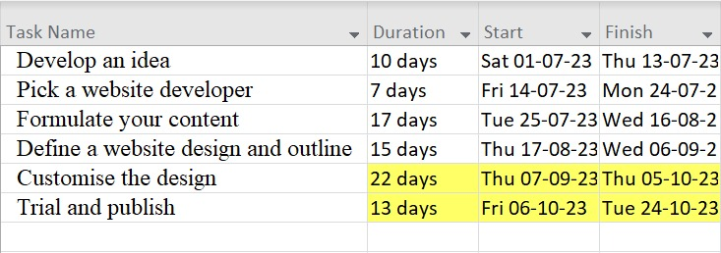

Figure 1: Gantt chart

***(Source: Self-Developed)***

The above-mentioned project plan will be helpful in aching the goal in specified timeframe. Initially the concept for the website development will be finalised and after that a team of developers will be selected that will be working on development process. Once the team is selected then that team will work on development of the content that is required to be included in the website. Furthermore, website design and outline will be designed which will be followed by customisation in the design according the needs of the client. In the last testing of the website will be done and all the issues will be resolved and after that the website will be published.

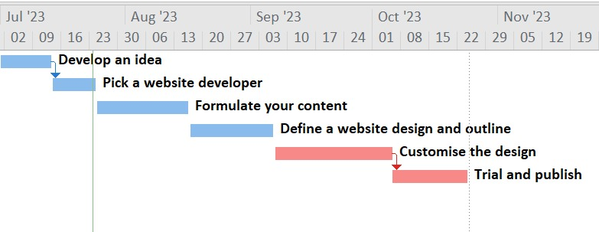

Figure 2: Critical path

***(Source: Self Developed)***

# Project budget and Earned Value Management analysis

## Project Budget

Table 2: Budget of the project

|  |  |
| --- | --- |
| Particulars | Amount |
| Resources |  |
| web developers | € 488.00 |
| designers | € 655.00 |
| content creators | € 360.00 |
| SEO specialists | € 445.00 |
| Domain name |  |
| annual | € 25.00 |
| multi-year registration fees | € 35.00 |
| Web hosting |  |
| VPS | € 88.00 |
| cloud | € 105.00 |
| Platform for the website | € 555.00 |
| Web development and Design | € 1,250.00 |
| Responsive design | € 255.00 |
| Media and Graphics |  |
| costs of acquiring high-quality images | € 366.00 |
| graphic designer | € 125.00 |
| E-commerce services | € 360.00 |
| Marketing and Search Engine Optimization (SEO) |  |
| online marketing campaigns | € 125.00 |
| social media ads | € 136.00 |
| Google Ads | € 112.00 |
| Reserves | € 120.00 |
| Security options | € 166.00 |
| Updates and Maintenance | € 90.00 |
| Quality assurance and testing | € 363.00 |
| Support | € 266.00 |
| Outsourcing | € 388.00 |
| Total | € 6,878.00 |

## Earned Value Management analysis

Earned Value Management (EVM) analysis is a project management technique that is used to evaluate a project's progress, performance, and cost efficiency. It incorporates scope, schedule, and cost measurement to provide insights into project performance and estimate future results (Mahmoudi, Bagherpour and Javed, 2019). To analyze project performance and detect potential difficulties or deviations, EVM analysis compares intended values, actual costs, and earned value.

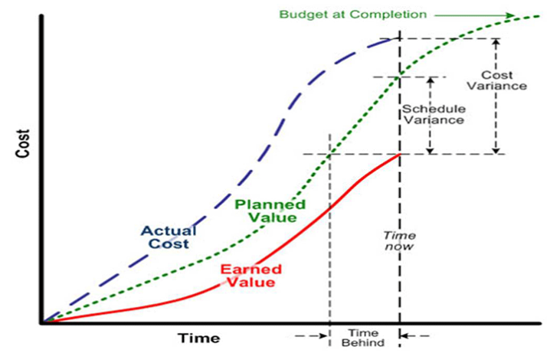

Figure 3: Earned Values analysis

The work in the project is completed by 50%. So based on that the earned value analysis is presented in the below table.

Table 3: Earned value analysis

|  |  |  |  |  |  |  |
| --- | --- | --- | --- | --- | --- | --- |
| Item | Planned Cost | Actual Cost | % of Work Completed | Earned Value | Cost Variance | Schedule Variance |
| Web Developers | 488 | 488 | 0.5 | 244 | 244 | -244 |
| Designers | 655 | 655 | 0.5 | 327.5 | 327.5 | -327.5 |
| Content Creators | 360 | 360 | 0.5 | 180 | 180 | -180 |
| SEO Specialists | 445 | 445 | 0.5 | 222.5 | 222.5 | -222.5 |
| Domain Name - Annual | 25 | 25 | 0.5 | 12.5 | 12.5 | -12.5 |
| Multi-year Registration Fees | 35 | 35 | 0.5 | 17.5 | 17.5 | -17.5 |
| Web Hosting - VPS | 88 | 88 | 0.5 | 44 | 44 | -44 |
| Web Hosting - Cloud | 105 | 105 | 0.5 | 52.5 | 52.5 | -52.5 |
| Platform for the Website | 555 | 555 | 0.5 | 277.5 | 277.5 | -277.5 |
| Web Development and Design | 1250 | 1250 | 0.5 | 625 | 625 | -625 |
| Responsive Design | 255 | 255 | 0.5 | 127.5 | 127.5 | -127.5 |
| Media and Graphics | 366 | 366 | 0.5 | 183 | 183 | -183 |
| Graphic Designer | 125 | 125 | 0.5 | 62.5 | 62.5 | -62.5 |
| E-commerce Services | 360 | 360 | 0.5 | 180 | 180 | -180 |
| Marketing and SEO | 373 | 373 | 0.5 | 186.5 | 186.5 | -186.5 |
| Online Marketing Campaigns | 125 | 125 | 0.5 | 62.5 | 62.5 | -62.5 |
| Social Media Ads | 136 | 136 | 0.5 | 68 | 68 | -68 |
| Google Ads | 112 | 112 | 0.5 | 56 | 56 | -56 |
| Reserves | 120 | 120 | 0.5 | 60 | 60 | -60 |
| Security Options | 166 | 166 | 0.5 | 83 | 83 | -83 |
| Updates and Maintenance | 90 | 90 | 0.5 | 45 | 45 | -45 |
| Quality Assurance and Testing | 363 | 363 | 0.5 | 181.5 | 181.5 | -181.5 |
| Support | 266 | 266 | 0.5 | 133 | 133 | -133 |
| Outsourcing | 388 | 388 | 0.5 | 194 | 194 | -194 |
| Total | 6878 | - | 0.5 | 3439 |  | - |

# Agile Roles in E-commerce Website Development

Various responsibilities are required in Agile project management for the effective development and distribution of the e-commerce website. The Product Owner, the Scrum Master, and developers have the key Agile roles (Cai et al., 2018). Here is a breakdown of these jobs, their responsibilities, and how they interact:

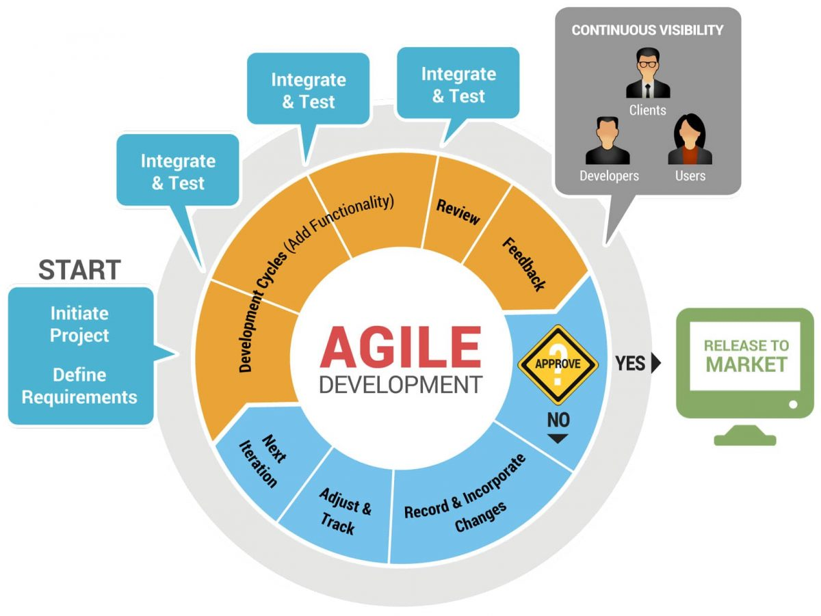

Figure 4: Agile Methodology

(Source: Vats, 2022)

## Product Owner

The product owner represent the company and is in charge of enhancing the value provided by the e-commerce website (Bass et al., 2018). Their key responsibilities include the following:

* Defining and prioritising the product backlog in accordance with company objectives and stakeholder requirements.
* Working with stakeholders to collect demands, define features, and verify consistency with business goals.
* Making judgments about the scope of the project, priorities, and trade-offs.
* Accepting or denying completed deliverables in accordance with preset acceptance criteria.
* Constantly communicating with the developers and various stakeholders to clarify issues and seek feedback.
* Participating actively in sprint evaluations and reviews to drive continual development.

## Scrum Master

The Scrum Master acts as an instructor and trainer for the Agile team, making sure that Agile standards and procedures are followed (Srivastava, Bhardwaj and Saraswat, 2017). Their primary responsibilities include: -

* Guiding the team in the adoption and implementation of Agile techniques such as Scrum.
* Enabling effective communication, cooperation, and self-organisation in the Development Team.
* Removing any impediments or roadblocks that hinder the team's progress.
* Facilitating sprint planning, daily stand-up meetings, sprint reviews, and retrospectives.
* Monitoring and promoting adherence to Agile practices, including timeboxing, iterative development, and continuous integration.
* Shielding the Development Team from external interruptions and distractions.

## Development Team

The Development Team consists of cross-functional individuals responsible for delivering the e-commerce website incrementally (Poth, Kottke, and Riel, 2020). Their key responsibilities include:

* Collaboratively designing, developing, and testing the features identified in the product backlog.
* Estimating and committing to the work to be accomplished during each sprint.
* Participating in sprint planning, daily stand-up meetings, sprint reviews, and retrospectives.
* Ensuring the quality of deliverables through continuous integration, testing, and adherence to development best practices.
* Collaborating with the Product Owner to clarify requirements and gather feedback.
* Self-organizing to optimize productivity and achieve sprint goals.

## Interactions between Roles

The Product Owner, Scrum Master, and Development Team interact closely throughout the e-commerce website development project:

* The Product Owner collaborates with the Development Team during sprint planning, providing insights into requirements and priorities.
* The Scrum Master facilitates effective communication and collaboration between the Product Owner and the Development Team, ensuring clear understanding of requirements and acceptance criteria.
* The Development Team actively engages with the Product Owner, seeking clarification, providing progress updates, and seeking feedback on deliverables.
* The Scrum Master acts as a coach, guiding the Product Owner and the Development Team in adhering to Agile principles and resolving any conflicts or impediments that may arise.

# Agile Techniques for Project Planning and Monitoring

## Scrum for ShopeEase Website Development:

**Sprint Planning:** Before each sprint, the project manager will meet with the Product Owner, the development team, and other stakeholders to discuss the upcoming sprint. The high-priority tasks for the forthcoming sprint will be chosen once they have reviewed the product backlog. The team will divide them into more manageable jobs and calculate how much work will be needed for each task. The team will be held accountable by the project manager for committing to a manageable amount of work for the sprint.

**Daily Stand-up:** The project manager will lead daily stand-up sessions where team members will offer updates on their progress, talk about any obstacles, and schedule their duties for the next day. During this meeting, the project manager will identify any obstacles that need to be removed and make sure that the team is on track to meet the sprint goals.

**Sprint Review:** The project manager will set up the sprint review meeting at the conclusion of each sprint, where the development team will show the Product Owner, designers, and other relevant parties the finished features and functionalities of the ShopeEase website. The project manager will see to it that the stakeholders offer their input and that any necessary changes are noted for upcoming sprints.

**Sprint Retrospective:** The project manager will lead the team in reflecting on the sprint's accomplishments and potential areas for improvement. The project manager will promote open dialogue and teamwork to find practical solutions that will improve the team's output and performance in the upcoming sprint.

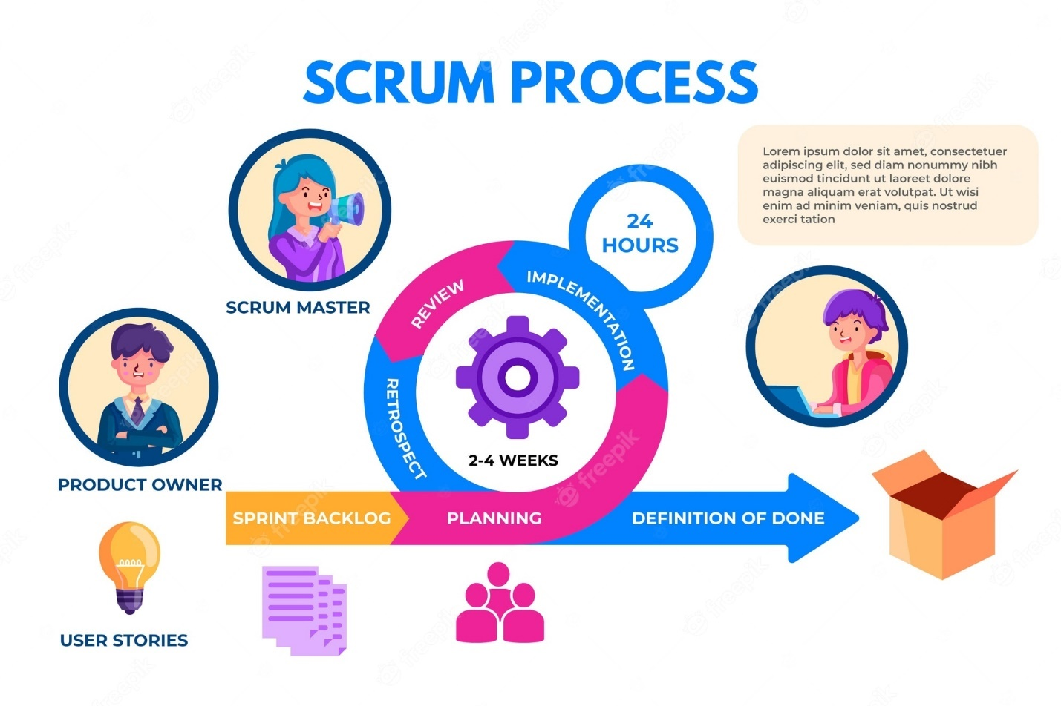

Figure 5: Scrum process

## Kanban for ShopeEase Website Development:

**Visual Board:** A Kanban board will be set up by me to reflect the various phases of the ShopeEase website's development, such as "To Do," "In Progress," and "Completed." The team will be able to track task progress and visualize the workflow using the board. The team members' ability to quickly check the progress of each work is ensured by the me, and project manager will also make sure that the board is updated frequently.

**WIP Limit:** On the Kanban board, the project manager will set work-in-progress restrictions for each stage of the workflow. To ensure a consistent workflow, project manager will make sure that the number of tasks that can be carried out concurrently. This keeps the staff from being overworked and makes ensuring that the task is completed efficiently.

**Continuous Delivery:** To ensure that finished work is regularly given to stakeholders, project manager will push the team to use a continuous delivery method. This will ensure that the website is always improving based on user wants and shifting requirements, assist validate the implemented features, and receive feedback early.

**Continuous Improvement:** project manager will arrange regular team meetings to examine workflow, find possibilities for process simplification, and boost productivity. The team will collaborate to create modifications that optimize the creation and delivery of the ShopeEase website while also discussing prospective upgrades.

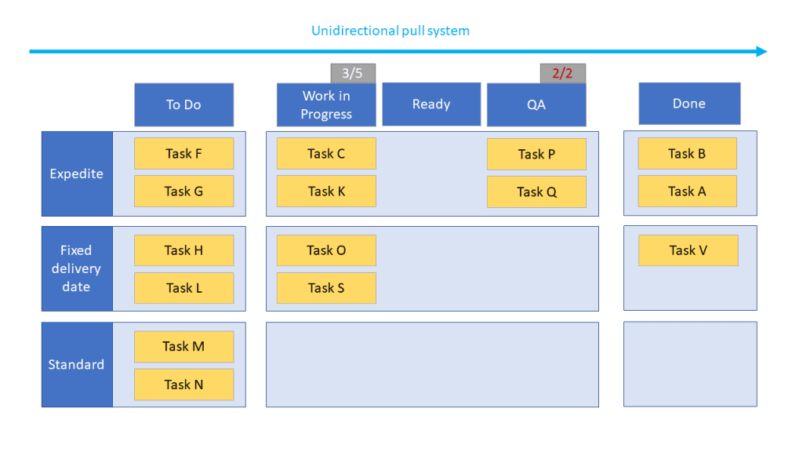

Figure 6: Kanban process

# Detailed Resourcing Plan aligned to tasks and activities

## Available resources as per the activities

**Project manager:** In charge of scheduling resources and managing deadlines for the entire project.

**Front-end developers:** Use HTML, CSS, and JavaScript to manage website design, layout, and interactive elements.

**Back-end developers**: should use PHP and MySQL to implement server-side features and database integration.

**UI/UX designers:** To design user interfaces, wireframes, and prototypes that are both aesthetically pleasing and intuitive.

**Quality Assurance Tester:** To carry out extensive testing and guarantee the website's dependability.

**Marketing and SEO experts**: to implement marketing strategies and increase website traffic and visibility.

**Support Team:** To provide continuing assistance and respond to consumer questions following launch.

**Database Administrator**: To oversee the website's database and guarantee the security and integrity of the information.

# Solution Development Team Management in ShopEase Website Development

To successfully manage the development team and assure the project's successful completion, as the project manager for the ShopeEase website development, project manager plan on putting the following techniques and methods into practice:

## Consistent Meetings:

***Figure 7: Consistent Meetings***

***(Source: Self developed)***

**Organize Sprint Planning Sessions:** project manager will work with the Product Owner and the development team to schedule the tasks for each sprint. In order to make sure that the team is in line with the project goals, we would prioritize items from the product backlog and create sprint targets.

**Daily Stand-up Meeting Facilitation:** project manager will organize daily stand-up meetings for the team to discuss their progress, resolve any problems or obstacles, and plan their daily duties. This encourages openness and makes sure the group stays on task.

**Organize Sprint Review Meetings:** project manager plans sprint review meetings at the conclusion of each sprint so that the development team could present to stakeholders the finished features and functionalities. We would solicit input, verify outputs, and make the necessary corrections for subsequent sprints.

**Facilitate Retrospective Meetings:** After each sprint, project manager will hold retrospective meetings to discuss the team's performance, pinpoint areas for improvement, and put plans into place to improve collaboration and productivity in coming sprints.

## Tools for Collaboration:

Figure 8: Tools for Collaboration

***(Source: Self developed)***

**Use Project Management Software:** To keep track of tasks, allocate responsibilities, and keep an eye on the development team's progress, project manager will use project management tools like Jira or Trello. This assists in properly managing project schedules by ensuring that everyone is informed of their roles and responsibilities.

**Leverage Communication Tools:** To promote rapid and effective communication among team members, project manager will advise the usage of communication tools like Slack or Microsoft Teams. It facilitates easy file sharing, real-time collaboration, and quick response to inquiries.

**Implement Version Control Systems:** project manager will use version control technologies like Git to effectively manage code changes. This makes it possible for the development team to coordinate code changes, keep track of revisions, and resolve any conflicts that may arise throughout the development process.

## Constant Improvement:

**Supporter of Continuous Integration (CI):** project manager will encourage the development team to implement continuous integration procedures. Regularly integrating code updates from different developers into a single repository would make it easier to identify integration problems early on, reduce the amount of work required for integration, and shorten feedback loops.

## Teamwork and Issue Resolution:

***Figure 9: Teamwork and Issue Resolution***

***(Source: Self developed)***

**Clearly Specify Tasks and Duties:** project manager will make sure that everyone on the team understood their duties, responsibilities, and fields of expertise. Clear task definitions facilitate effective work allocation and help prevent misunderstandings.

**Encourage Regular Communication and Knowledge Sharing:** project manager will encourage regular exchanges of information among team members in order to promote a collaborative environment. This enables cross-functional learning and raises the team's overall productivity.

**Develop Problem-Solving Skills:** project manager will encourage the team to adopt a problem-solving mentality by empowering individuals to take on problems on their own while offering help and direction when required.

**Address problems Quickly:** To address problems quickly and reduce their influence on the project, I would create conflict resolution protocols and promote open communication.

**Foster Trust and Respect:** Fostering a culture of respect and trust at work would enable team members to freely express their ideas, worries, and suggestions. Team members work more effectively together and produce better projects when there is mutual trust and respect among them.

# Communication with Business Stakeholders in E-commerce Website Development

## Communication Plan

Project manager will establish a thorough communication strategy to keep stakeholders aware and engaged throughout the ShopeEase development process.

* **Stakeholder Identification**: project manager will identify important stakeholders such as business owners, managers, marketing staff, and any other essential persons participating in the project. This will assist you understand their interests and needs.
* **Communication methods**: Depending on each stakeholder's preferences and accessibility, project manager will select appropriate communication methods such as email, online conferences, and software for project management to keep them updated and resolve their problems as soon as possible.
* **Time and Frequency**: project manager will set the frequency of interaction for each stakeholder, offering frequent updates to keep them interested without overloading them with information.
* **Reporting Structure**: Having a clear reporting system will assist guarantee that the appropriate information is sent to the appropriate parties. project manager will specify who will be in charge of interacting with every stakeholder and the degree of detail that will be supplied.
* **Paperwork**: To keep stakeholders informed, project manager will decide on the sorts of reports and papers that will be shared during the execution of the project, such as updates on progress, plans for the project, and meeting minutes.
* **Escalation method**: By implementing an escalation method, project manager will handle any major issues or obstacles that may occur throughout the development process as soon as possible, assuring fast resolution.

**Figure 10: Communication Plan**

**(Source: Self-developed)**

## Regular Status Reports

Project manager will send frequent status reports to partners to keep them up to speed on the development of the ShopeEase website.

Project manager will include the following in progress reports:

* **Summary of accomplishments since the last report**: This will emphasize the development process's progress, ensuring stakeholders are informed of the milestones attained.
* **Work done and forthcoming activities are summarized as follows**: Stakeholders will get visibility into the endeavour’s trajectory by highlighting accomplished tasks and forthcoming activities.
* **Deliverables and milestones reached**: Reporting on completed milestones will demonstrate to stakeholders the project's success and timeliness.
* **Revisions to expenditures and resources**: By providing information on expenditure and resource allocation, stakeholders will be able to examine the project's financial elements.
* **Risks and issues with mitigation techniques**: Visibility about possible risks and mitigation solutions assures stakeholders of successful risk management.
* **Change requests and their effect**: Clearly articulating change requests and their implications on the project will allow for more informed decision-making.

**Figure 11: Regular Status Reports**

**(Source: Self-developed)**

## Stakeholder Meetings

Throughout the project, project manager will organize several stakeholder meetings to build involvement and ensure consistency with their expectations.

* **Kick-off Meeting**: During the initial meeting with stakeholders, project manager will outline the project's aims and scope, ensuring that stakeholder expectations are aligned with the project goals.
* **Prerequisites Review Meetings**: project manager will include stakeholders in gathering requirements for the project and making scope changes to ensure the website fulfils their business goals.
* **Regular Meetings**: Through regular meetings, project manager will offer updates on project development, resolve issues, and react to stakeholder questions.
* **Sample Sittings**: Stakeholders will be able to see finished features, offer input, and check that their demands are being met during demo sessions.
* **Retrospective Meetings**: Following the end of a project, stakeholders will be able to analyse outcomes, gain useful insights, and discuss future improvements.

**Figure 12: Stakeholder Meetings**

**(Source: Self-developed)**

## Incorporating and Gathering Feedback

project manager will aggressively acquire and incorporate input from stakeholders throughout the project to guarantee a successful website development.

* **Mechanisms for Obtaining Review**: project manager will provide specific avenues for stakeholders to contribute their ideas and comments, such as survey forms, email, and organized feedback meetings.
* **Consistent Participation**: Engaging stakeholders on a regular basis throughout the project's life cycle will ensure timely and meaningful input, which can be leveraged to match the creation of the website with their demands.
* **Assessment and Prioritization**: project manager will study and analyse stakeholder comments to discover common themes and prioritize changes or improvements that are in line with the project's goals (Moreau, Gagnon and Boudreau, 2015).
* **Examination**: Establishing a change control method will allow for a complete examination of requested adjustments, taking into account scope, scheduling, and cost effects.
* **Transparent Conversations**: project manager will communicate openly about how feedback from stakeholders will be reviewed, incorporated, or handled, therefore establishing trust and successfully managing expectations.

**Figure 13: Incorporating and Gathering Feedback**

**(Source: Self-developed)**

# Agile Techniques and On-Time Project Delivery in ShopEase Website Development

## Agile Techniques for Requirement Prioritization:

**Prioritization according to MoSCoW:** project manager will work closely with the product owner and other stakeholders to identify and classify requirements into categories such as "Must have," "Should have," "Could have," and "Won't have" at the moment. With this prioritizing, the team can concentrate on providing the most important features first and save the less important ones for later versions.

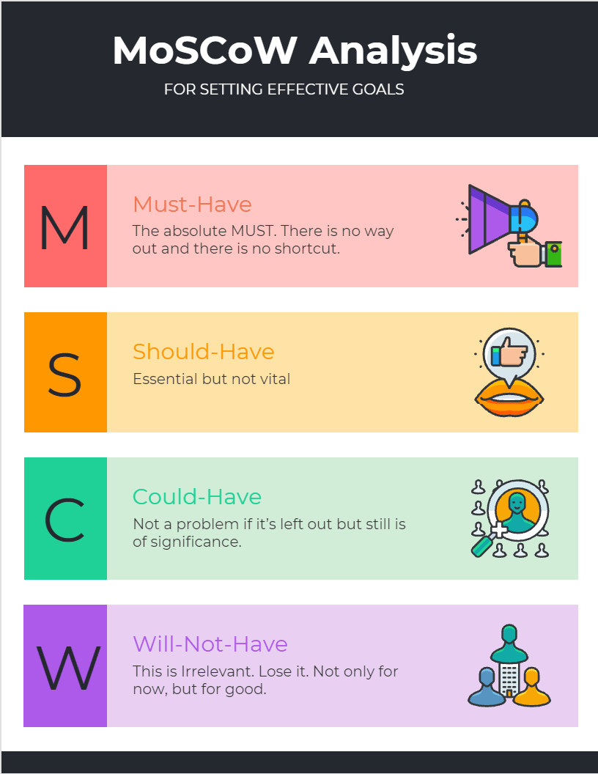

Figure 14: MoSCoW Prioritization

**User narrative Mapping:** To construct a user narrative map for ShopeEase, the development team and stakeholders will collaborate with me to organize group workshops. In order to discover and prioritize user stories based on their significance and impact on the final product, this will provide us a comprehensive view of the user experience.

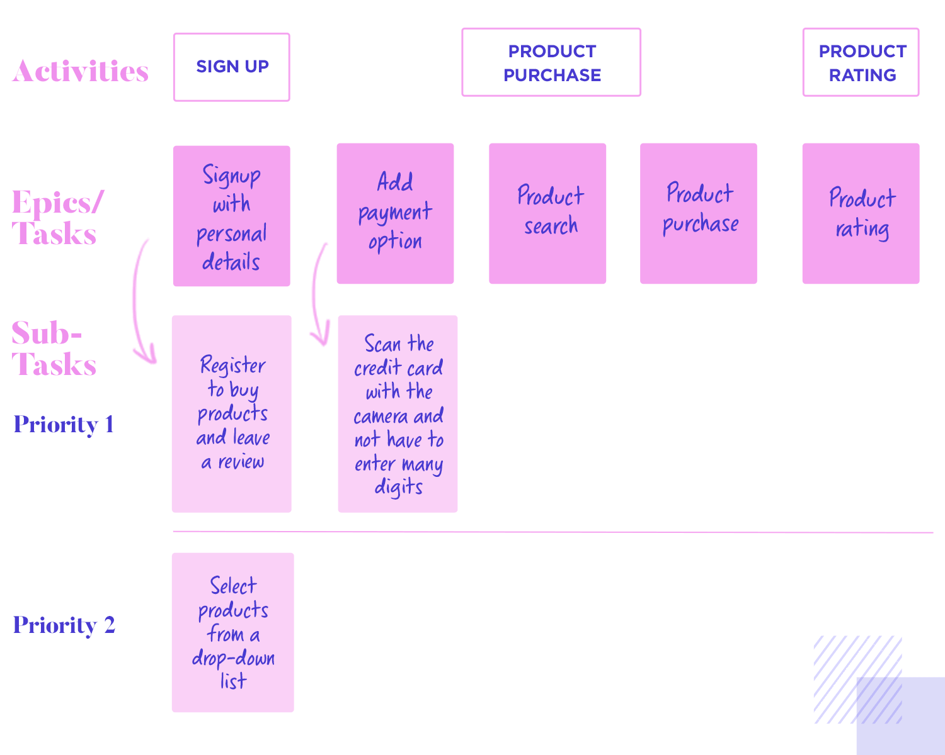

Figure 15: User narrative Mapping

**Value-Based prioritizing:** project manager will include important stakeholders in sessions of value-based prioritizing, where we will value requirements according to their effects on the business, the value of the customers, and the return on the investment. High-value features are prioritized and created early in the project thanks to this method.

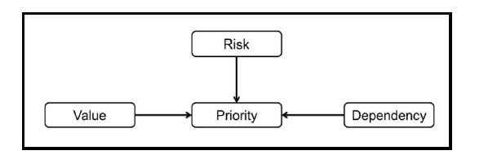

Figure 16: Value-Based prioritising

**Kano Model:** project manager will make use of the Kano model to classify needs in accordance with how they affect customer satisfaction in order to find features that have the potential to please customers and add value. This will direct our efforts as we concentrate on capabilities that can provide us a competitive edge and raise customer satisfaction.

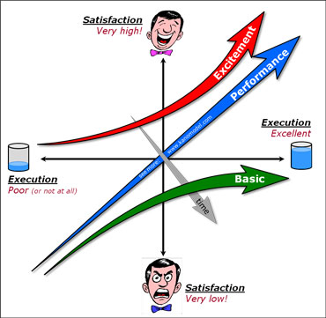

Figure 17: Kano Model

## Iterative and Incremental Nature of Agile Development:

Figure 18: Iterative and Incremental Nature of Agile Development

***(Source: Self-Developed)***

**Sprints or Iterations:** project manager will divide the development process into brief, predetermined sprints that run two to three weeks on average. Each sprint will produce functional increments that could be released. At the conclusion of each sprint, the team will analyze its performance, enabling ongoing feedback and adjustment.

**Continual Feedback:** Daily stand-up meetings will be held to encourage regular feedback and communication among team members. Additionally, we will host sprint review sessions at the conclusion of each sprint to get input from stakeholders on the provided increments. This input will be used in succeeding sprints to tighten requirements and guarantee that the project continues to meet the expectations of stakeholders.

**Minimal Marketable Product (MMP):** Early versions will be focused on developing a ShopeEase Minimal Marketable Product (MMP), according to the team. This MVP will have crucial components that can be swiftly introduced to the market, enabling early value delivery and gathering user input for additional improvements.

**Continuous Improvement:** project manager will lead sprint retrospective meetings as the project manager at the conclusion of each sprint. The team will be able to review its procedures during these retrospectives, pinpoint areas for improvement, and make the required modifications to increase communication and output.

# Risk Management in ShopeEase Website Development

As the project administrator for the ShopeEase website development, project manager will use the risk management approaches listed below to assure the project's achievement and reduce any issues:

## Identifying Risks

Project manager I will undertake a thorough risk analysis to identify any risks that might affect the ShopeEase website development's delivery, time, budget, or quality.

* **Technical Risks**: project manager will evaluate technological risks such as device and browser compatibility difficulties, data security shortcomings, and possible performance bottlenecks. By recognizing these risks early on, project manager may incorporate suitable mitigation measures during development.
* **Stakeholder Risks**: Throughout the project, project manager will be cautious about stakeholder involvement and participation. Identifying risks like as shifting needs, a lack of involvement, or competing agendas will allow me to handle these issues ahead of time, guaranteeing a seamless relationship with stakeholders (Torrecilla-Salinas et al., 2015).
* **External Risks**: project manager will examine outside factors such as regulatory changes, fierce competition dynamics, and supplier reliance. Knowing about these external influences allows me to make contingency plans for any potential disruptions.
* **Project Management Issues**: Risks related with project management include risks linked with project planning, allocation of resources, scope creep, and interaction. Identifying the management of project risks will aid in the development of solid project management methods to guarantee timely delivery and scope adherence.

**Figure 19: Identifying Risks**

**(Source: Self-developed)**

## Risk Register

For the ShopeEase web design project, project manager will keep a risk register that serves as a consolidated repository for detected hazards and their data.

* **Risk Description**: Each risk will be defined in depth, including its characteristics, its potential effect on the project, and areas it may influence.
* **Probability and Impact**: project manager will evaluate each risk's likelihood of occurrence as well as its possible impact on project objectives. This evaluation will aid in selecting risks and concentrating on those with the greatest impact.
* **Risk Owner**: project manager will appoint a risk owner who will be in charge of monitoring and managing risks throughout the project's lifespan. This promotes responsibility and timely action if the danger occurs.
* **Mitigation Strategies**: project manager will establish particular mitigation strategies for each identified risk, such as emergency preparations, preventive activities, or alternate ways. If dangers are identified, having set methods in place will allow for rapid actions.
* **Reserves for Contingencies**: project manager will assess the resources, time, and money that may be necessary to handle identified risks. Providing contingency reserves will assist in dealing with unexpected obstacles without jeopardizing project progress.

**Figure 20: Risk Register**

**(Source: Self-developed)**

## Qualitative and Quantitative Risk Assessment

To analyze the highlighted hazards for the ShopeEase website creation, I will use qualitative as well as quantitative risk assessment methodologies.

* **Quantitative Risk Evaluation**: To statistically analyze the likelihood and possible impact of some significant hazards, project manager will use quantitative approaches such as Monte Carlo simulations. This will allow for a better data-driven knowledge of risk vulnerability and will help with decision-making (Halin et al., 2019).
* **Qualitative Risk Evaluation**: For additional hazards, project manager will undertake qualitative evaluations using subjective criteria such as probability and effect levels. This method will aid in risk prioritization based on qualitative findings.

**Figure 21: Risk Register**

**(Source: Self-developed)**

## Risk Thresholds and Tolerances

* **Risk Tolerances**: Setting acceptable risk levels for every undertaking objective, such as timing, money, quality, and satisfaction among stakeholders, will help guide decision-making when confronted with uncertainty. This guarantees that risk responses are consistent with previously specified tolerances.
* **Risk Thresholds**: By establishing predefined triggers or limits, such as surpassing a particular budget shortfall or missing a vital milestone, project manager may quickly launch suitable risk response measures. This keeps risks from rising and having a detrimental impact on the project.

**Figure 22: Risk Thresholds and Tolerances**

**(Source: Self-developed)**

# Stakeholder analysis

Table 4: Stakeholder analysis

|  |  |  |  |  |
| --- | --- | --- | --- | --- |
| Name of Stakeholder | Impact Level | Level of Support | Reason for Resistance | Action to Be Taken |
| Product Owner | High | Strong Support | N/A | Continue collaboration and involve in decision-making processes. |
| Development Team | High | Strong Support | N/A | Provide resources, support, and clear communication channels. |
| UX/UI Designers | Medium | Strong Support | N/A | Encourage creativity and regular feedback sessions to meet design needs. |
| Marketing Team | Medium | Strong Support | N/A | Collaborate on product launches and promotional activities. |
| Customers | High | High Support | N/A | Conduct user surveys and collect feedback for continuous improvement. |
| Project Manager | High | Strong Support | N/A | Ensure project goals and objectives are met, and address any challenges. |
| CEO/Management | High | Strong Support | N/A | Regularly communicate project progress and seek approval on key decisions. |
| IT Support Team | Medium | Strong Support | N/A | Collaborate to ensure seamless integration and resolve technical issues. |
| Competitors | Medium | Neutral Support | Market Competition | Monitor competitor strategies and differentiate to attract customers. |
| Investors | High | Neutral Support | Financial Risk | Provide regular updates on project progress and financial stability. |
| Regulators/Government | High | Strong Support | Compliance Requirements | Ensure adherence to regulations and obtain necessary approvals. |
| Suppliers | Medium | Neutral Support | Business Relations | Maintain good relations and timely procurement of required resources. |

# Risk Register

***Table 5: Risk Register***

|  |  |  |  |
| --- | --- | --- | --- |
| Risk Description | Likelihood Criteria | Impact Criteria | Score (LxI) |
| Data Breach | High | High | High |
| Website Downtime | Medium | High | Medium-High |
| Scope Creep | Medium | Medium | Medium |
| Budget Overrun | Medium | Medium | Medium |
| Technical Compatibility Issues | Low | High | Medium-Low |
| UX/UI Design Delays | Medium | Medium | Medium |
| Cybersecurity Vulnerabilities | Medium | Medium | Medium |
| Supplier Delivery Delays | Low | Medium | Low-Medium |
| Lack of Customer Adoption | Low | Medium | Low-Medium |
| Changes in Regulatory Landscape | Low | Low | Low |

# References

Bass, J.M., Beecham, S., Razzak, M.A., Canna, C.N. and Noll, J., 2018, May. An empirical study of the product owner role in scrum. In *Proceedings of the 40th International Conference on Software Engineering: Companion Proceeedings* (pp. 123-124).

Mahmoudi, A., Bagherpour, M. and Javed, S.A., 2019. Grey earned value management: theory and applications. *IEEE Transactions on Engineering Management*, *68*(6), pp.1703-1721.

Poth, A., Kottke, M. and Riel, A., 2020. Evaluation of agile team work quality. In *Agile Processes in Software Engineering and Extreme Programming–Workshops: XP 2020 Workshops, Copenhagen, Denmark, June 8–12, 2020, Revised Selected Papers 21* (pp. 101-110). Springer International Publishing.

Sugahara, T., Inoguchi, M. and Nakano, K., 2017. Development of Balance Validation System for Work Breakdown Structure in Disaster Response based on Project Management Framework. *IEICE Technical Report; IEICE Tech. Rep.*, *116*(422), pp.139-143.

Moreau, M., Gagnon, M.P. and Boudreau, F., 2015. Development of a fully automated, web-based, tailored intervention promoting regular physical activity among insufficiently active adults with type 2 diabetes: integrating the I-change model, self-determination theory, and motivational interviewing components. *JMIR research protocols*, *4*(1), p.e4099.

Torrecilla-Salinas, C.J., Sedeño, J., Escalona, M.J. and Mejías, M., 2015. Estimating, planning and managing Agile Web development projects under a value-based perspective. *Information and Software Technology*, *61*, pp.124-144.

Halin, A., Nuttinck, A., Acher, M., Devroey, X., Perrouin, G. and Baudry, B., 2019. Test them all, is it worth it? Assessing configuration sampling on the JHipster Web development stack. *Empirical Software Engineering*, *24*, pp.674-717.

Srivastava, A., Bhardwaj, S. and Saraswat, S., 2017, May. SCRUM model for agile methodology. In *2017 International Conference on Computing, Communication and Automation (ICCCA)* (pp. 864-869). IEEE.

Cai, L., He, X., Dai, Y. and Zhu, K., 2018, September. Research on B2B2C E-commerce website design based on user experience. In *Journal of Physics: Conference Series* (Vol. 1087, No. 6, p. 062043). IOP Publishing.